Chapter 5, Problem 6

Using the same parameters for the 741 op amp in Example 5.1, find v_{o} in the op amp circuit of Fig. 5.45.

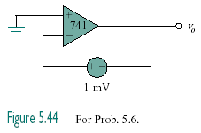

Figure 5.45
For Prob. 5.6.

Example 5.1

A 741 op amp has an open-loop voltage gain of 2×10⁵, input resistance
of 2 MΩ, and output resistance of 50Ω. The op amp is used in the circuit
of Fig. 5.6(a). Find the closed-loop gain v_{o}/v_{s} . Determine current i when
v_{s} = 2 V.

